Thank you to all our 2018 sponsors!

Platinum Plus $500

Montanti Family

Dr. Joseph English III, MD

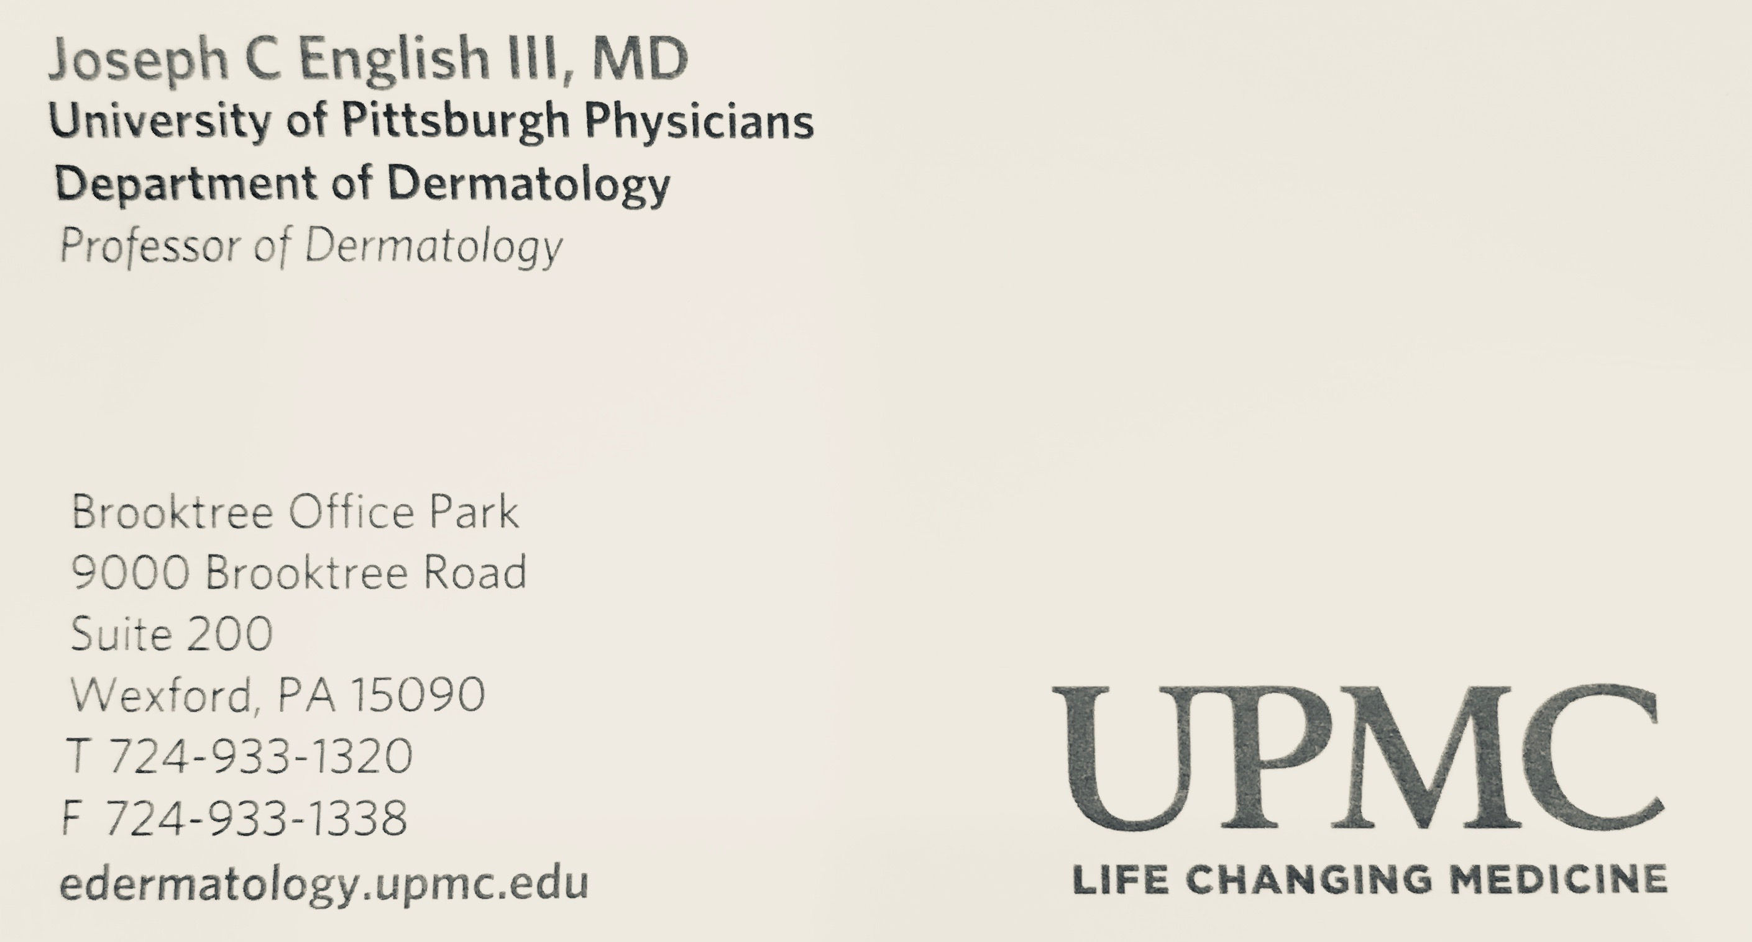

Platinum $250

Achieve Realty

Swartout Financial/Northwestern Mutual

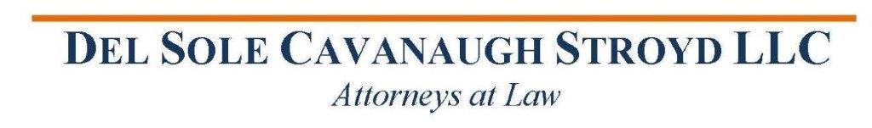

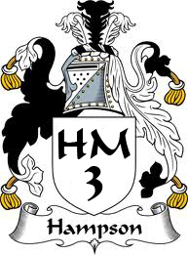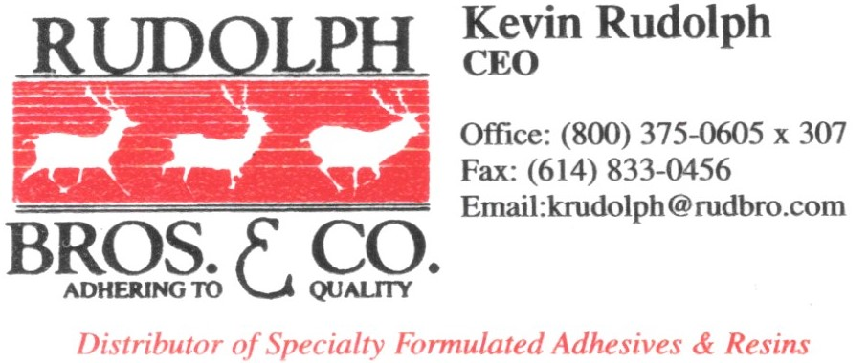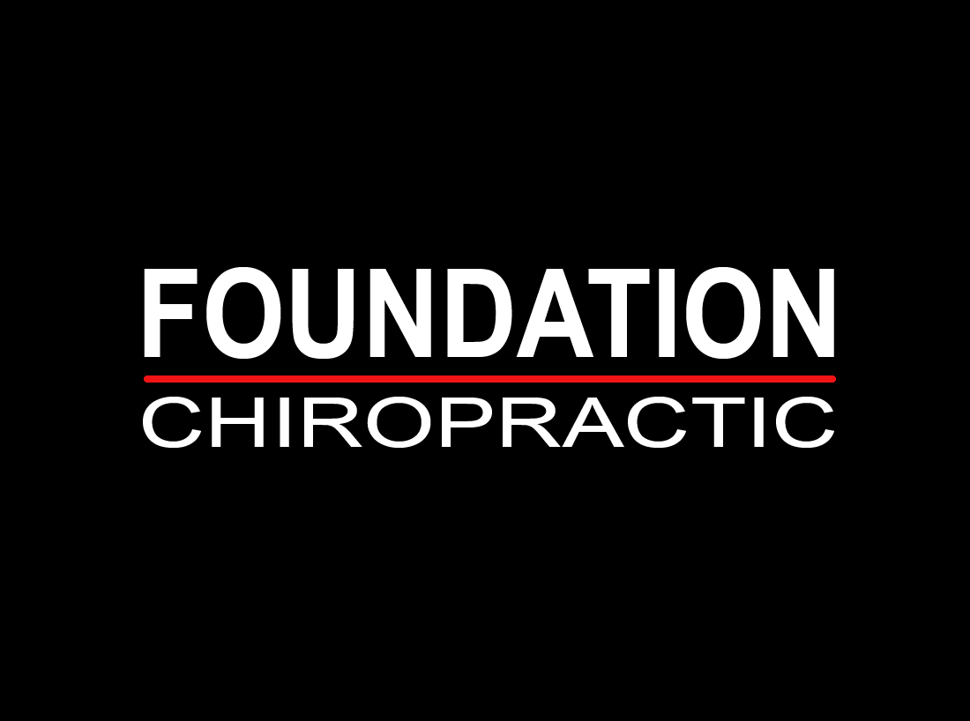

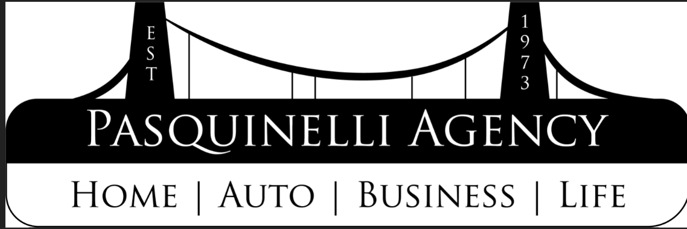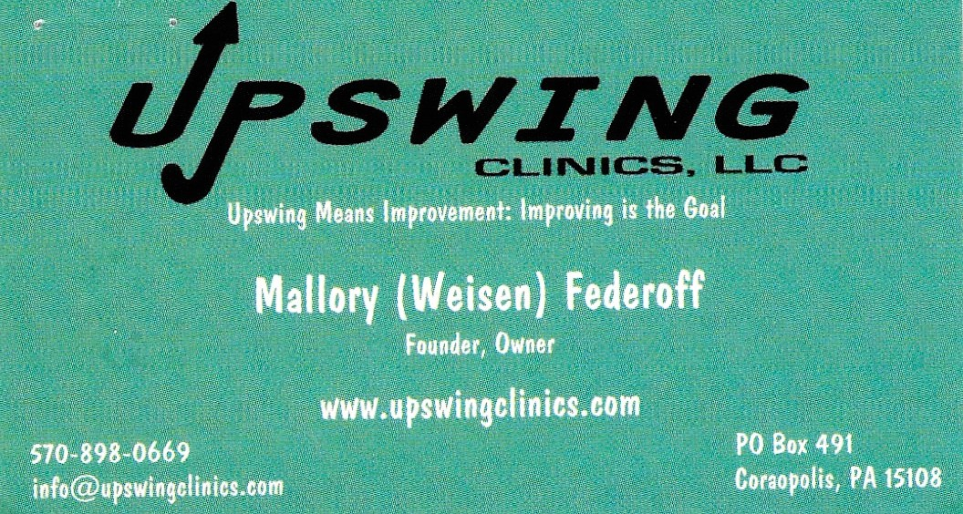

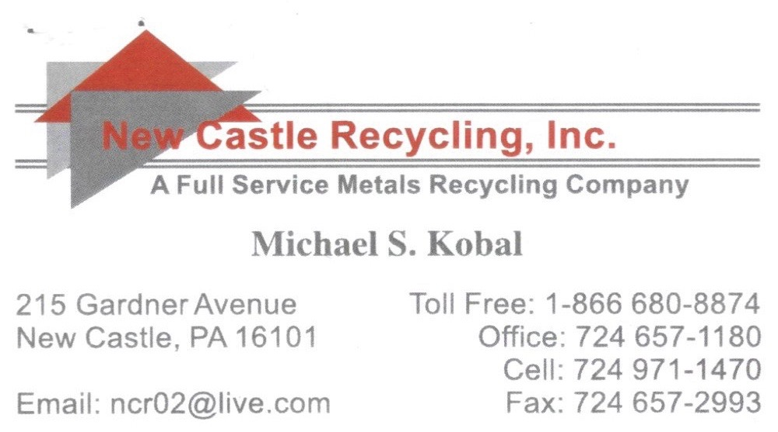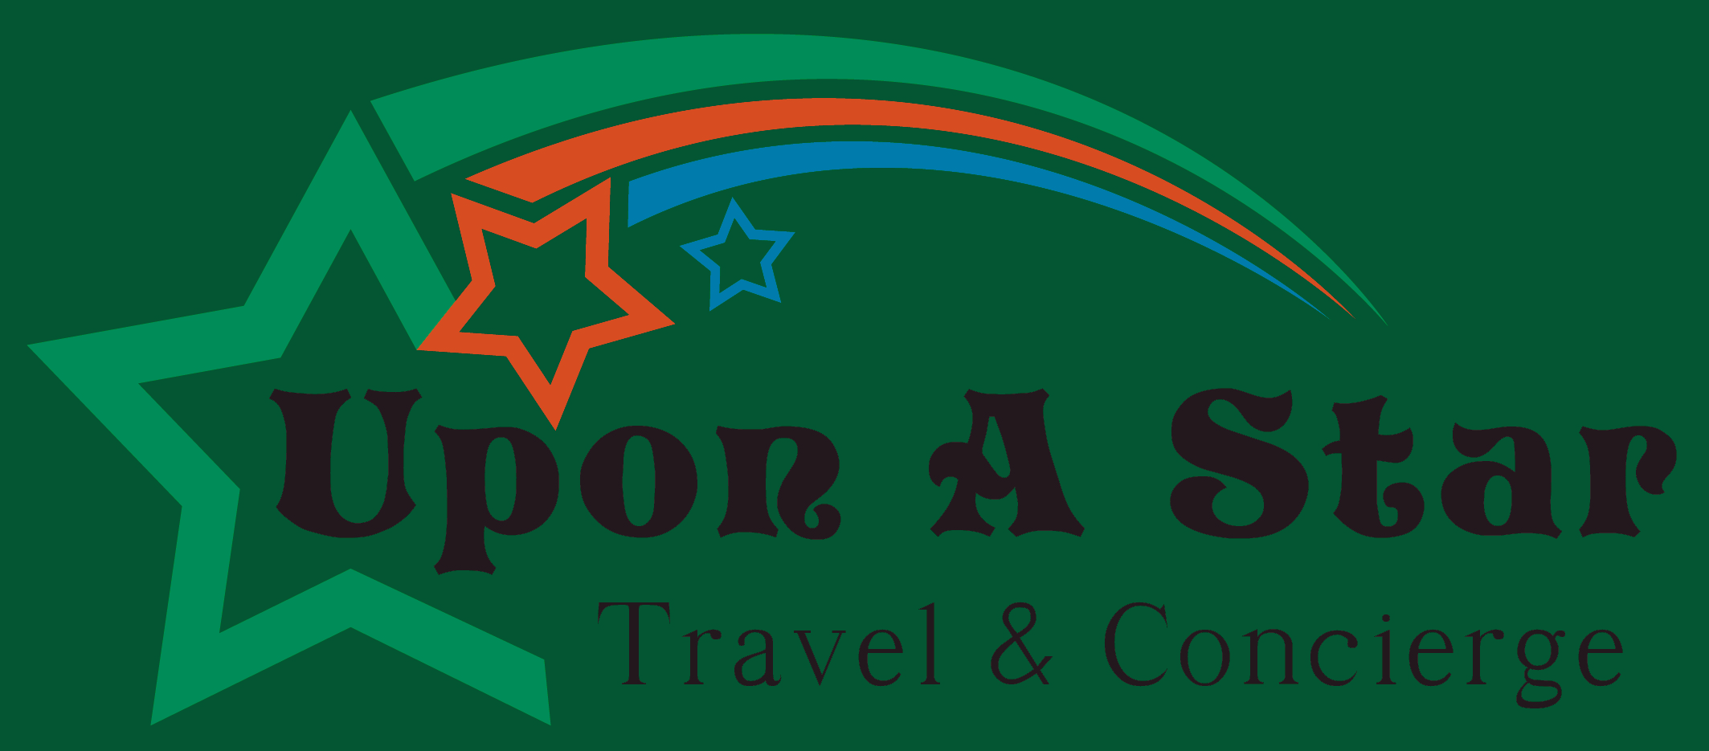





Gold $150

Rulis & Bochicchio

King Orthodontics

The Dawn Landis Team – Berkshire Hathway



Silver $100

Butler Health System

Ditto

Dave Sutter Auto Body

Jezebel Boutique

Kappa Sigma IUP Indians

Knichel Logistics

Mazur & Kirsch Directory

PAS LLC

Pittsburgh Venom Field Hockey Club

Waddell’s Music Center

David Weber, MD

Bronze $50

Awards and More

Cala Lily

Complete Chiropractic Health

GKG Orthodontics

Insurance Services

Natural Lawn of America

Paul Ferugheli

Ready Nutrition

Rottinghaus Family

Stepping Stones

Young Life Pittsburgh