PERFORMANCE EATING FOR SOCCER
Leslie Bonci, MPH,RD- UPMC Center for Sports Medicine
(412)432-3674 or email: boncilj@upmc.edu

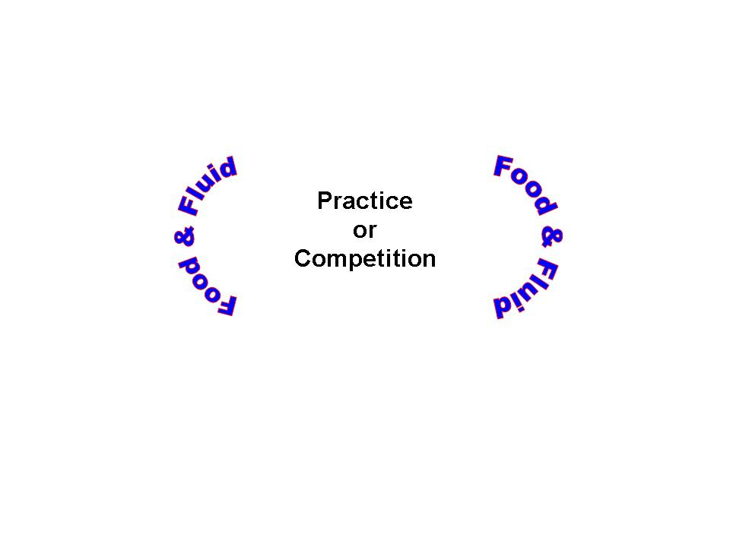

1. DRINK ENOUGH
MINIMUM NUMBER OF OUNCES PER DAY = Middle school 70 ounces High school- 90 oz

Coffee, tea, milk, juice, water, soda, sports drinks all count as fluid as well as fruits, vegetables, soups, gelatin, fruit ices
NEED TO THINK ABOUT DRINKING EARLY AND OFTEN AND ESTABLISH A HYDRATION PLAN:
A loss of as little as 2 % of body weight due to dehydration can increase fatigue and impair performance!
Drinking enough can increase stamina up to 33% longer

How do you know if you are dehydrated?
Noticeable thirst Muscle cramps Weakness Impaired performance
Headache Nausea Fatigue Burning in stomach
Dry mouth Dizziness/lightheadedness

BASELINE NEEDS:
16-20 ounces of fluid within 10 minutes of waking up
10-20 ounces of fluid with every meal
10-12 ounces with every snack
10-20 ounces BEFORE BED

PRE EXERCISE
Start exercise with some fluid already in your stomach- If you are too nervous or uncomfortable to eat- consider Gatorade PRIME to put some fuel in your body before practice or games
20 oz 1 hr before exercise- OR 10 ounces 15 minutes BEFORE either water or Gatorade- and if you haven’t eaten before practice/conditioning choose a Gatorade instead of water for the carbohydrate

HOW TO CONSUME FLUID DURING EXERCISE
Larger gulps over sips
Swallow fluids, do not spit
Drink, don’t pour on your head
Do NOT overdrink
Drink 3 cups of fluid for every pound lost
Gatorade/G2 over water during exercise
Be careful with energy drinks
5 hr energy will not provide fluid for your muscles on the field!

AFTER PRACTICE/GAMES
Drink enough to replace losses- 24 ounces of fluid for every pound you lose during exercise
Consider Gatorade Recover to provide fluid, carbohydrate, protein and sodium
Do a urine check the next morning AFTER exercise
Does your urine look more like lemonade than apple juice?
Did your thirst subside?

2.ADD SALT IF NECESSARY
If you are a salt loser, you need to use more!
Salty sweat or Salty residue on skin or uniform/clothes
Eat salty foods such as pickles, pretzels
Use salt, Soy or Worcestershire sauce
Use sports drinks instead of water to provide sodium and help replace what is lost through sweating
Consider adding salt to a sports drink. One-quarter teaspoon added to 20 ounces of sports drink or one-half teaspoon of salt added to 32 ounces of sports drink

3.MEAL FREQUENCY
Make sure to eat enough times during the day
Eat within 1 hour of waking up- you need to eat breakfast or your body plays catch up all day which means you are tired during practice as well as in the classroom or at the workplace
Try to eat small meals every 4 hours
Calorie intake should be a range of 18-23 calories per pound body weight

4.EMPHASIZE CARBOHYDRATES ON THE PLATE

2/3 of the plate as rice, pasta, potato, bread, cereal, fruit, vegetables
Fuel for muscles during activity and Fuel for the brain during exercise
Good sources of carbohydrate include:
Bread Bagels Tortillas Rice Pasta Quinoa Crackers Juice
Barley Potatoes Corn Fruit Vegetables Pretzels

Try to Limit:
Pastries Cookies Candy Ice cream Fruit drinks/soda chips/fries
These foods contain carbohydrate but also contain high amounts of fat and/or sugar

5.EAT ENOUGH PROTEIN FOR MUSCLE GROWTH AND A HEALTHY IMMUNE SYSTEM
0.5 x body weight (pounds) is the MINIMUM number of grams of protein a day
1/3 of the plate as chicken, fish, meat, eggs, cheese, soy foods nuts, seeds, beans
PROTEIN AT BREAKFAST:
Cheese- sliced, Laughing Cow, baby Bel, String cheese, or 5-6 cheese cubes
Egg
Cottage cheese
Greek yogurt
A shake
A smoothie
Cheese on a bagel, not cream cheese
Peanut butter on an English muffin
Bar such as Power, Special K, Clif, Zone, Balance, Nugo

!
Do include some protein as part of every meal and snack:
Eggs Jerky Nuts Peanut butter Baked beans Bean dip
Chicken Turkey Beef Pork Fish/shellfish Tofu
Eggs Low-fat milk Yogurt Lower fat cheeses

Try to limit:
Bacon Sausage Pepperoni Whole milk Fried meats
Full fat cheeses Hot dogs

These foods do contain protein but are also high in fat and saturated fat which is not as healthy for the body

6.FAT IS AN ESSENTIAL FUEL FOR EXERCISE
Add some as part of every meal as a spread, peanut butter, salad dressing, or in a food such as cheese, meat, or even a fried food
There is no need to cut fat out of the diet
Limit BEFORE exercise as they can upset your gut!
Do include some fat as part of every meal and snack
Good sources of fat includes:
Nuts Seeds Nut butters Olives Olive oil Pesto Avocados
Guacamole Mayonnaise Sunflower, corn, safflower, soybean, corn oils
Soft margarines

Try to limit:
Creamy dressings Creamy sauces Sour cream Cream cheese
Lard Butter Shortening Stick margarines

These foods are sources of fat, but are primarily saturated or trans fats which are not as healthy

7.TIMING IS EVERYTHING
Try to eat every 4 hours to give your body maximal energy over the day
Eat breakfast
Snack mid morning if you have late lunch or snack mid-afternoon if you have early lunch
Dinner
Evening snack if you have an early dinner
Eat something within 15 minutes of exercise such as sports drink, cereal bar, trail mix, bar or Gatorade Recover to help your body recover more quickly
Protein + Carbohydrate after practice/games- within 30 minutes can help you to recover faster
Protein sources (g) Carbohydrate sources (g)
2 TBSP peanut butter- 14 ½ of a bagel- 25 grams
8 oz yogurt- 10 8 oz yogurt- 40 grams carbohydrate
12 oz low-fat chocolate milk- 12 12 oz low-fat chocolate milk- 30 grams
¼ cup nuts- 10 grams 1 cup cereal- 30 grams
2 hard cooked eggs- 14 grams 2 slices of toast- 30 grams

7.FOODS TO INCLUDE RIGHT BEFORE AND DURING GAMES/TOURNAMENTS
Honey sticks Jello Sugar cubes Dry cereal Chex mix
Mini pretzels Sports drinks Honey packet Crackers
Gels Individual gel shots Gatorade Prime
Gatorade Recover Fruit Dried fruit Sports drink

EATING BEFORE PLAY or PRACTICE
1 hour before:
20 ounce of sports drink or 20 ounces of water with:
A handful of pretzels or cereal or a granola bar
OR
Gatorade Prime + 10 ounces of water

DURING PRACTICE OR PLAY
30 grams of carbohydrate per hour by consuming:
16 ounces of sports drink
A gel or bloks or shots
A packet of honey or 2 honey sticks
OR Gatorade PRIME

AFTER PRACTICE OR PLAY
Drink enough to replace sweat losses- 24 ounces of fluid for every pound you lose during exercise
Eat something or drink something with calories within 15 minutes of practice or play
2 handfuls of pretzels, crackers or cereal
OR
2 handfuls of trail mix
OR
A higher carbohydrate sports bar or 2 granola bars
OR
A piece of fruit and a small handful of pretzels
OR
Gatorade Recover

8. SUPPLEMENTS
Vitamin D- 1000 IU
Calcium- 1300 milligrams especially if you don’t eat dairy foods or drink milk

SAMPLE MENU
BREAKFAST
8 ounce yogurt with ¼ cup granola
A banana
6 ounce glass of juice
12 ounce glass of water

MID AM SNACK ( if you have late lunch)
A Special K bar

LUNCH
Sandwich on a roll
3 slices of meat
1 slices of cheese
Piece of fruit
Crackers, pretzels or baked chips- 1 handful
12 ounce glass of milk, juice or lemonade+ 12 ounce glass of water

PREPRACTICE
Sports drink 20 ounces + a handful of Chex mix

POST PRACTICE
Gatorade Recover OR
10 ounce bottle of low-fat chocolate milk

DINNER
4-5 ounces of lean meat, poultry or fish
1 cus of pasta, rice or potatoes
2 cups of vegetables- either cooked or salad
12 ounce glass of milk, juice or lemonade + 8 ounce glass of water

EVENING SNACK
Bowl of cereal( 1 cup) with fruit and milk ( 8 ounces)+20 ounces of water

